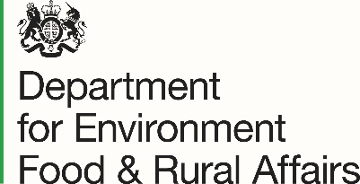
Farming in Protected Landscapes Programme Enquiry Form

Thank you for your interest in the Farming in Protected Landscapes programme. To help us deal with your enquiry, please complete the following information. We will respond to you as soon as possible and aim to respond within 10 working days.
Before you complete this enquiry form it would be helpful if you have read the guidance on our website –https://www.northwessexdowns.org.uk/farming/farming-in-protected-landscapes/
Many thanks in advance for your patience.

Date:
Name:
Email:
Contact telephone number:

What is the name of your holding?:
SBI:
Holding location (please include address/postcode and/or grid ref number):
Can you describe your farm/holding (size, type (arable/livestock etc)

Do you own the land included in the proposed project? Yes/No
If No, do you have landowner permission to undertake the project? Yes/No

Is the land included part of, or includes part of, a common? Yes/No
If Yes, do you have a formal internal agreement with all commoners? Yes/No

Are you acting on behalf of an applicant or group of applicants or are you the sole applicant?

Are there any designated features on the project land such as SSSI or SAM? Yes/No
If Yes, have you consulted with the relevant public body? Yes/No

Are you currently in an agri-environment scheme? Yes/No
Have you ever been in an agri-environment scheme? Yes/No
If Yes, please state which scheme with dates:

Are you in the SFI pilot? Yes/No

Is your holding in part located within the North Wessex Downs National Landscape? Yes/No

If no, why is your project relevant to the aims of the NWD management plan?

If you have an idea for a project already, please give us a few details. Please include any rough ideas of costs and timescales.

I would like to receive further information about farming in the AONB: Yes/No
I would like to receive the North Wessex Downs AONB newsletter: Yes/No

Thank you for your interest - please email to me or FiPL@northwessexdowns.org.uk

Privacy Statement
When you submit your formal application, you consent to the North Wessex Downs AONB sharing any information provided to the Department for Environment, Food and Rural Affairs (Defra) – including their arm’s length bodies, including Rural Payments Agency, Natural England and Forestry Commission – for the monitoring of the programme and to complete dual funding check processes.
With respect to the processing of Your personal data, the North Wessex Downs AONB, Defra and its arm’s length bodies will implement and maintain appropriate technical and organisational measures to ensure a level of security appropriate to that risk, including, as appropriate, the measures referred to in Article 32(1) (a), (b), (c) and (d) of the retained EU law version of the General Data Protection Regulation (Regulation (EU) 2016/679), transposed into UK Law by the Data Protection, Privacy and Electronic Communications (Amendments etc) (EU Exit) Regulations 2019).
North Wessex Downs AONB is committed to protecting and respecting your privacy, and we’ll only use your personal information to provide the information and services you request from us.

