Overview of The North Wessex Downs 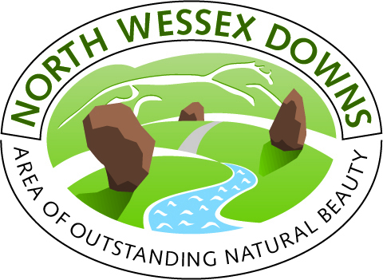
The North Wessex Downs is a tranquil yet stunning landscape of rolling chalk downlands, forests, woods and dales. Beech woodland crowns the tops of many of the downs providing wonderful panoramic views for miles around. Thinly populated, the downs project a feeling of remoteness and timelessness. In the vast skies above, skylarks, lapwings and majestic birds of prey can be seen.

The world famous Uffington White Horse and Avebury Stone circle are located on the Ridgeway path running across the north of the region along with many other ancient barrows and hill forts.

Close to major conurbations, the Downs is the ideal place to get away from it all and enjoy the freedom of the countryside while respecting the environment. There are many footpaths, horse riding trails and cycle paths criss-crossing the landscape and taking in many of the best views and ancient monuments. If you prefer to travel by water you can hire a canal boat or go canoeing along the Kennet and Avon Canal.

The North Wessex Downs has a great industrial heritage. At the Crofton Pumping Station on the
Kennet and Avon Canal, you can see the world’s oldest steam engines or visit the only working windmill in Wessex at Wilton. There are also fine country houses. Highclere Castle (Downton Abbey) has impressive staterooms, an Egyptian exhibition and wonderful grounds to walk.

The picturesque market towns and villages of the Downs have much to offer. If you like browsing antiques there are lots of dealers in Marlborough, Hungerford and Pewsey. For those with an interest in history there are fascinating museums and visitor centres in Devizes, Pewsey, Wantage and Whitchurch. During the summer, many of the towns and some of the larger villages have music and arts festivals, carnivals plus special events around Christmas.

