Food and Farming 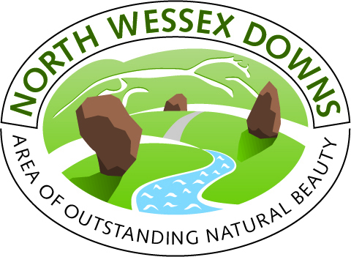
More and more people are keen to sample local food and drink when visiting the North Wessex Downs. Eating, drinking and buying local produce is seen as an important part of appreciating the flavour and distinctiveness of an area. The Downs is fortunate in having some very high quality food producers who supply local restaurants, pubs and shops. Most of the market towns including Marlborough, Hungerford, Devizes and Wantage have their own community or farmers markets which showcase local produce and are great places just to visit.
Flikr photostream; http://www.flickr.com/photos/101655312@N04/sets/72157635490995657/
Market Days
If you’ve ever wanted to know where local food comes from, how it is grown, and ideas for cooking it, then visit one of the Farmer and Community Markets held every month in Berkshire, Hampshire, Oxfordshire and Wiltshire. This is one of the best ways to meet the people who grow superb fruit and vegetables, make delicious cheese, bread and preserves, and produce tasty meat. They are always happy to have a chat about their products.
In addition to Farmer and Community Markets, many towns and villages in the North Wessex Downs AONB have weekly street markets. There are also food events, such as the Hungerford Food Festival in September, or plenty of stalls at the Wiltshire Show in June and the Royal Berkshire show in September. Information about local farmers and food producers in the area can be found on our interactive map.
Farm and Wildlife Experiences
You can see life on the farm at a number of places in and around the North Wessex Downs. Bucklebury, Finkley Down and Laverstoke Farm Parks, Four Kingdoms Farm, Cholderton Charlies and Roves Farm are open come rain or shine! Other farms welcome visitors during lambing season (generally March to May) and many more take part in Open Farm Sunday in mid June. Beale Park, the Nature Discovery Centre, Butterfly World and the Hawk Conservancy Trust can also offer an up close view of wildlife.
A Tipple (or Two!)
There are Vineyards in Littleton Parnell, Laverstoke Park Farm and Brightwell that are open to tours. Try cider and apple juice from producers like Ciderniks, the Lambourn Valley Cider Co., and Tutts Clump. A revival in real ale is good news for Butts, Ramsbury, Three Castles, Plain Ales, Wadworths and West Berks breweries. It is also notable that the chalk geology of the North Wessex Downs is remarkably similar to that of the Champagne region in France, so who knows if we may hear the popping of corks someday?
Meat
Farmland of the North Wessex Downs helps to rear some high quality meat. You can source wonderful sausages from pork reared at Welford Park or Brunskill beef from Francombe Farm. Family owned butchers like Walter Rose in Devizes, Bastable Brothers of Kintbury, Sumblers in Marlborough and Three Trees Farm at Chiseldon serve the best cuts. Many pubs and restaurants are known for sourcing local meat, especially the Pot Kiln in Frilsham where TV Chef Mike Robinson even runs a game and wild food cookery school.
Bread and Cakes
Award winning flour is milled at Doves Farm, Clarks of Wantage and also at the historic Wilton Windmill. Wonderful cakes and pastries can be found at small bakeries such as Marshalls of Pewsey, Great Bedwyn Bakery and the Old Farmhouse Bakery in Kintbury. Why not try Lardy Cake, a Wiltshire speciality, or the Marlborough Bun. To unleash your creative side, Cakes by Cocochoux offers cake baking and decorating courses.

