Art and Literature 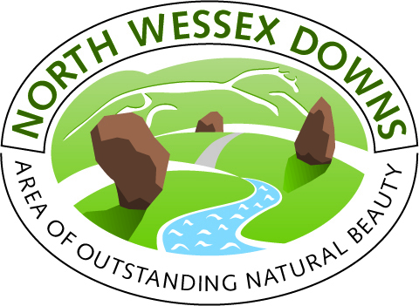

The landscape of the North Wessex Downs has left an impression on many artists and writers throughout history. There are several Stanley Spencer (1891-1959) paintings of the North Wessex Downs around Burghclere and Beacon Hill. Other work includes the series of 19 paintings influenced by the Great War which are in the Sandham Memorial Chapel, Burghclere.

Eric Ravilious (1903-1944) painted the White Horses at Uffington and Westbury as part of a series intended for illustrations in a book. Paul Nash (1889-1946) had a special affinity for the Wittenham Clumps which he first encountered as a teenager. He was immediately caught by their atmospheric shapes and mystical associations and called them ‘a beautiful legendary country’.

Many artists continue to take inspiration from the North Wessex Downs. Anna Dillon recently painted the ‘Icons of the North Wessex Downs’ series, while the Wiltshire Museum in Devizes is home to ‘Cartoon for a Stained Glass Window’ by John Piper, among other works.

Numerous authors have written about the area and perhaps the most famous novel is ‘Watership Down’ (1972) by Richard Adams.

Thomas Hardy visited and knew the area around Wantage. Arabella’s cottage in Jude the Obscure is in Letcombe Bassett and Fawley is depicted as Marygreen. John Betjeman (1906-1984) spent much time in the North Wessex Downs and the lines about the Upper Lambourn summarise the landscape well:

Feathery ash in leathery Lambourn
Waves above the sarsen stone
And Edwardian plantations
So coniferously moan
As to make the swelling downland
Far-surrounding, seem their own.

Many other authors have been influenced by these surroundings including Agatha Christie who is buried at Cholsey, Jane Austen, who spent much time in the area and writes of the landscapes in many novels, and Thomas Hughes who based the semi autobiographical ‘Tom Brown’s Schooldays’ at Uffington where he had lived.

Landscape
This is pure downland, the breasted hills curved as if under the influence of a great melody. It is beautiful, quiet and unrenowned and a most visibly ancient landscape.
Edward Thomas

Jefferies often thought of the sea upon these hills. The eye expects it. There is something oceanic in their magnitude, their solitude… They are never abrupt, but, flowing on and on, make a type of infinity… they have a hugeness of undivided surface for which there is no comparison on earth.
From Richard Jefferies: His life and Work (1909), Edward Thomas

The slopes of the downs, if they have general forms, are continually changing and interchanging in localities, assuming new and strange shapes, charming and surprising with their grace and exquisiteness… for ever reflecting the mood of the heavens...
Alfred Williams

At length the snow ceases and the wind drops to a whisper; then over the hill-top the lapwings start up again and wheel in phantom flight, shrieking their weird night call.
From The Woodland Life (1897), Edward Thomas

The Ridgeway
A broad green track runs for many a long, long mile across the downs, now following the ridges, now winding past at the foot of a grassy slope, then stretching away through a cornfield and fallow.
From Wildlife in a Southern Country (1879), Richard Jefferies

... at once it [the Ridgeway] strikes you out and away from the habitable world in a splendid purposeful manner, running along the highest ridge of the Downs, a broad green ribbon of turf...

Out on that almost trackless expanse of billowy Downs such a track is in some sort humanly companionable; it really seems to lead you by the hand.
From Pagan Papers (1898), Kenneth Grahame

